**Reeco frontend developer assignment:**

**Prerequisites:**

1. Open a Github repository called “Reeco”
2. Make a new react project with redux.

**Task:**

Implement the following screen as precisely as possible. The screen describes an order that was done in the system.

Main page

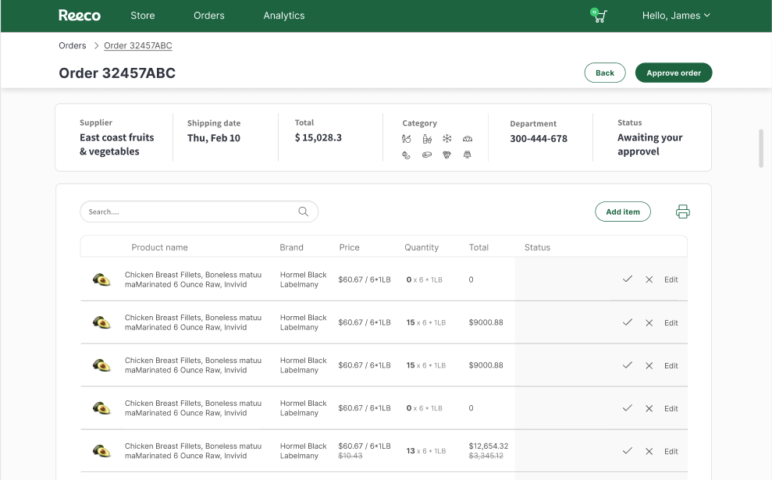

When shipping date arrives and until user approves the order, he can update the status of each product by clicking on the CTAs on the right:

1. Clicking  will mark the product as approved
2. Clicking  will mark the product as “Missing” or “Missing – Urgent” depend on user selection (in the next figure)
3. **(Optional)** Click “Edit” will open an edit popup

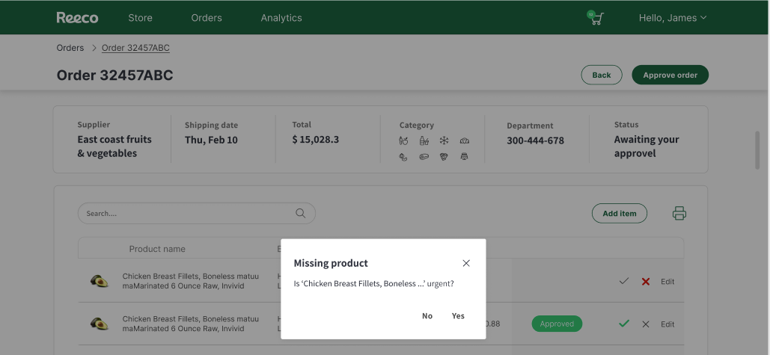**Missing – Urgent Popup**

**Edit – Popup (Optional)**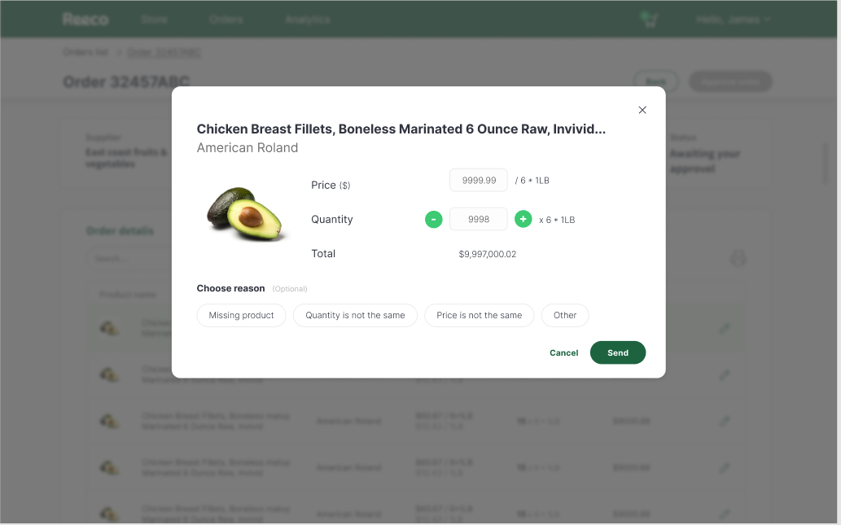

**Edit Requirements (Optional):**

1. User can update the product price (price >= 0)
2. User can update the product quantity (quantity >= 0)
3. User needs to select a reason

**Main screen after updates**

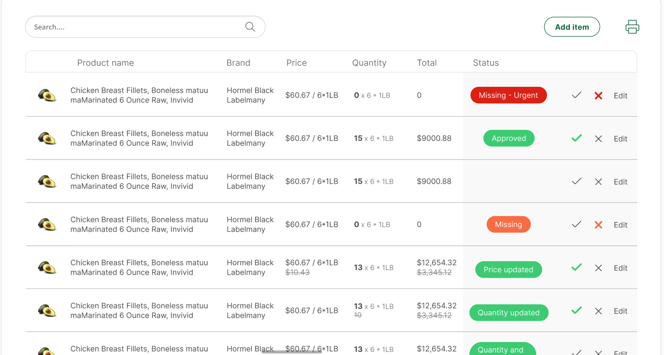

**Comments:**

1. In the zip folder you have all the images you need
2. The text is not important at all, put “lorem ipsum” or dummy text
3. Styling is important but functionality is much more.
4. The “Edit” logic is optional flow.

**Good to have but not mandatory:**

1. Use styled components instead of traditional CSS.
2. Use redux toolkit instead of the old redux
3. Instead of making the data hard coded make a separate file a JSON with the relevant data as a mock and mock a BE call to receive the data.

Feel free to contact me on any question

Good luck!